

REPORT OF ASSIGNMENT 2:

Name | Ayesha Shabbir
Registration no: | 25I-8037
Instructor name: | Sir Mateen Yaqoob
Subject: | Data science tools and techniques
Assignment | 2

TASK 1:
Task 1: Data Analysis (30 Marks):
Using Dataset #1 (dataset.csv):
• Perform data preprocessing to fix issues in the dataset:
✓ Handle missing values.
✓ Detect and treat outliers.
✓ Remove duplicate rows.
• Perform EDA (Exploratory Data Analysis):
✓ Summary statistics (mean, median, variance)
✓ Distribution plots (histograms, density plots).
✓ Boxplots for outlier detection.
• Identify which features follow normal, uniform, skewed, or multimodal patterns.
- Identification of missing values:
In attached dataset file, I used data.isnull().sum() to identify total number of missing values in each feature. Its output is shown as:
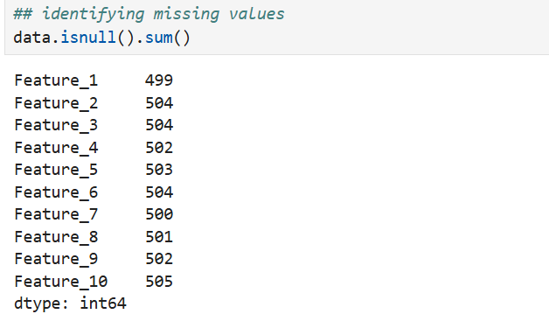
Identification of outliers:
I used box plot to check the presence of outliers, in this dataset, outliers are present in feature 1 and feature 2 as shown in figure.
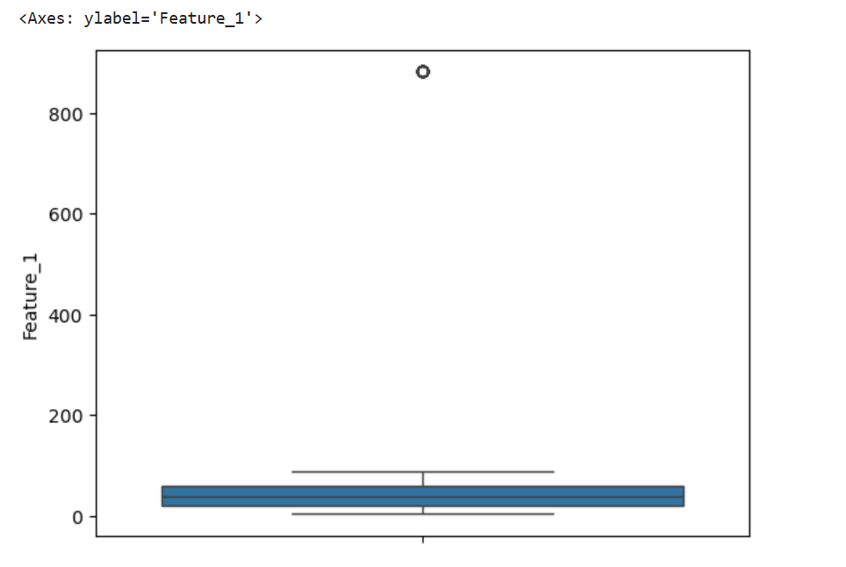
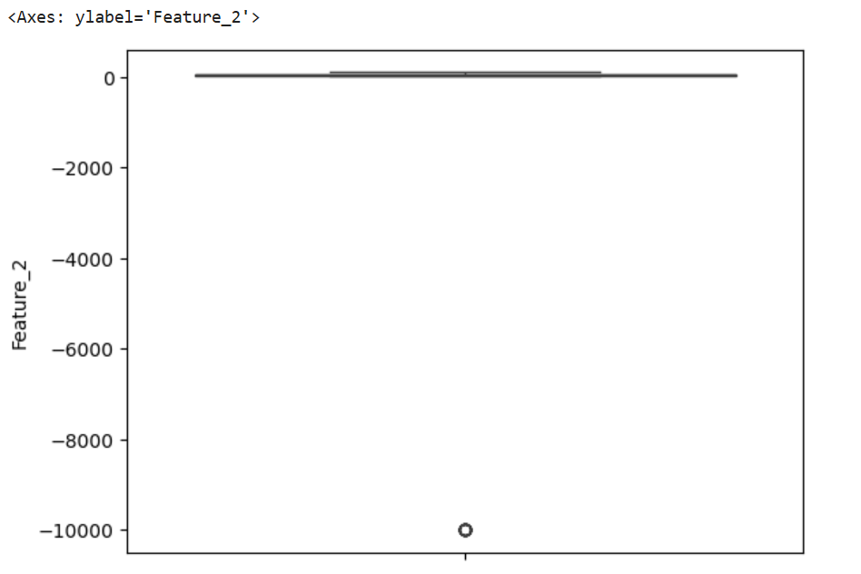
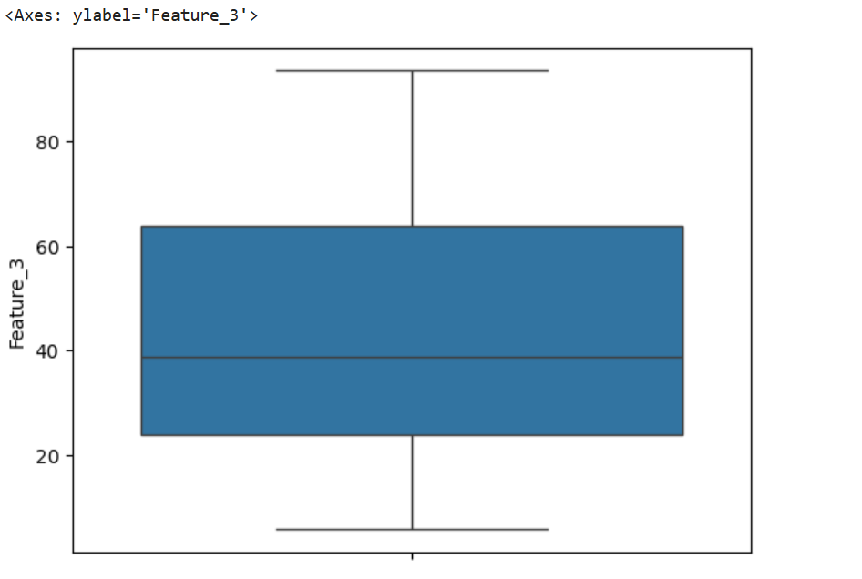
Identification of duplicated rows:
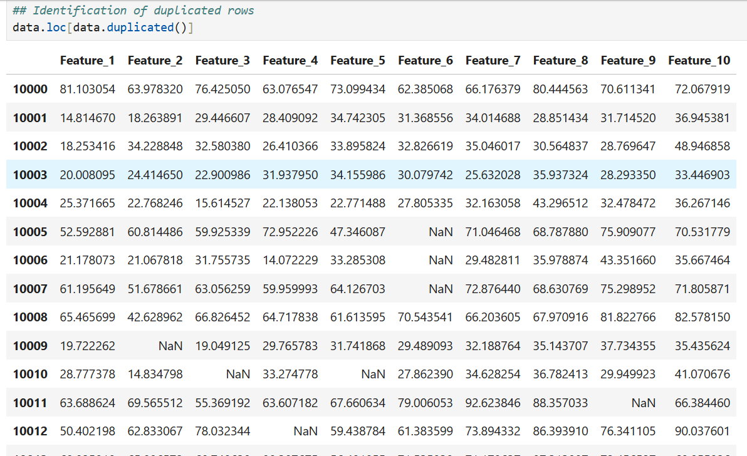
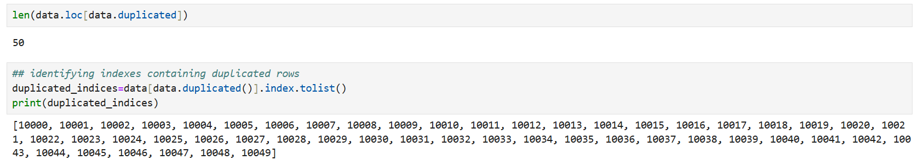
Data pre-processing:
Handling duplicated rows:
Duplicated rows are dropped from dataset as shown in figure:
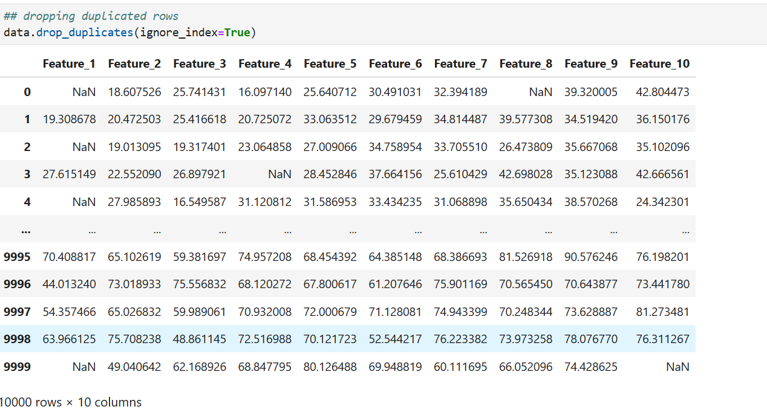
Handling missing values:
Missing values present in features are filled by taking median also shown in this figure:
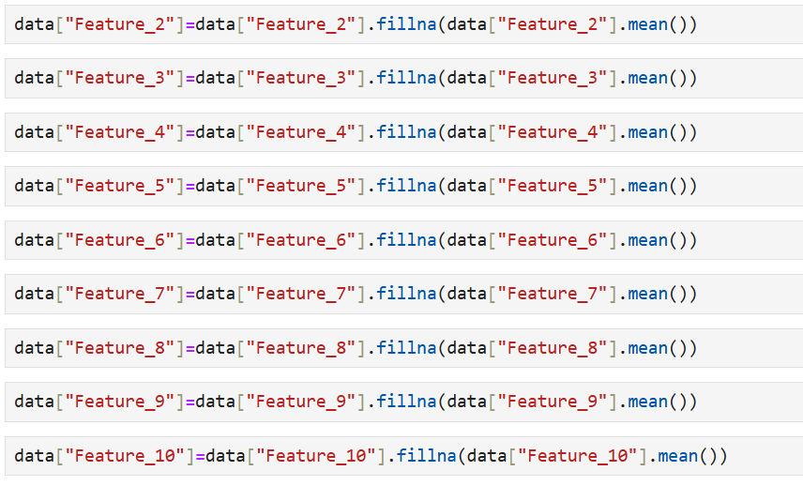
After filling missing values:
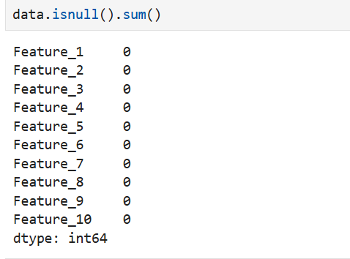
Removing outliers:
I had removed outliers by calculating inter quartile range and by using lower bound and upper bound and removing row containing values of feature 1 and feature outside of this range.
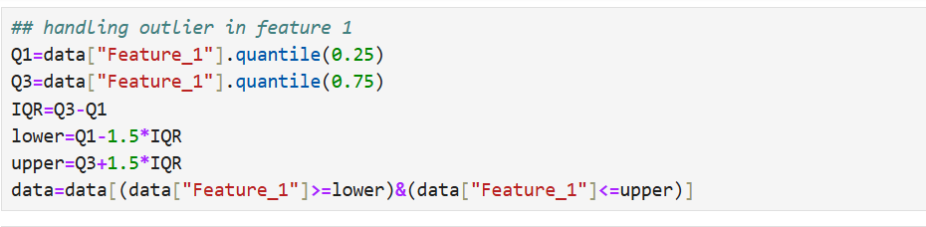
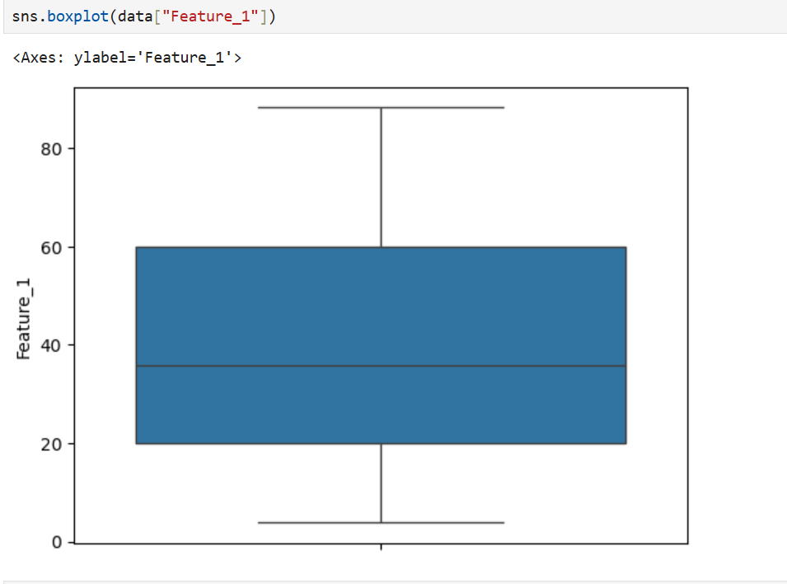
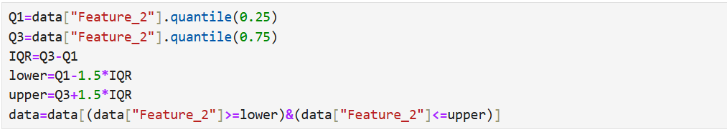
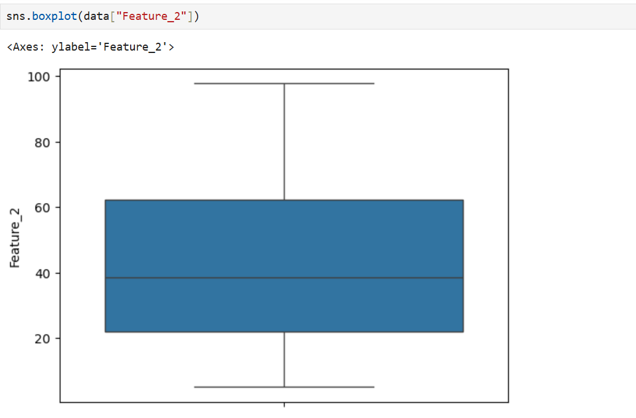
Summary statistics:
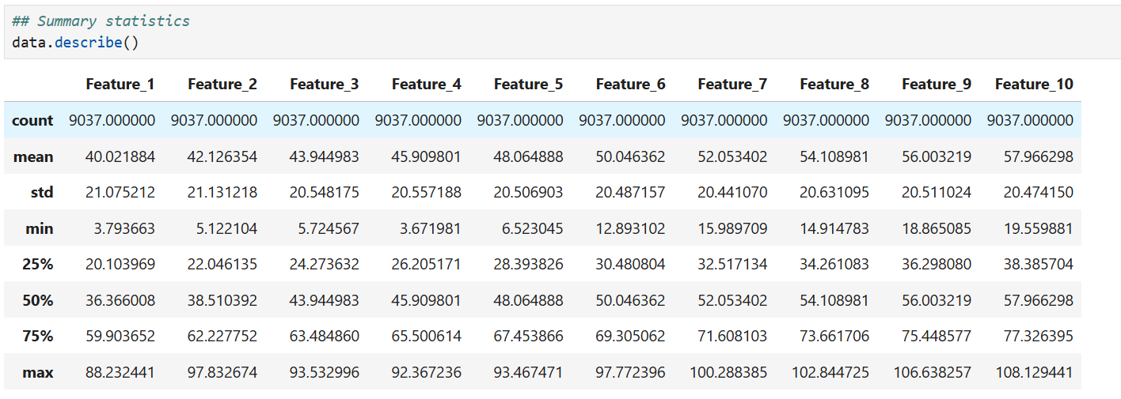
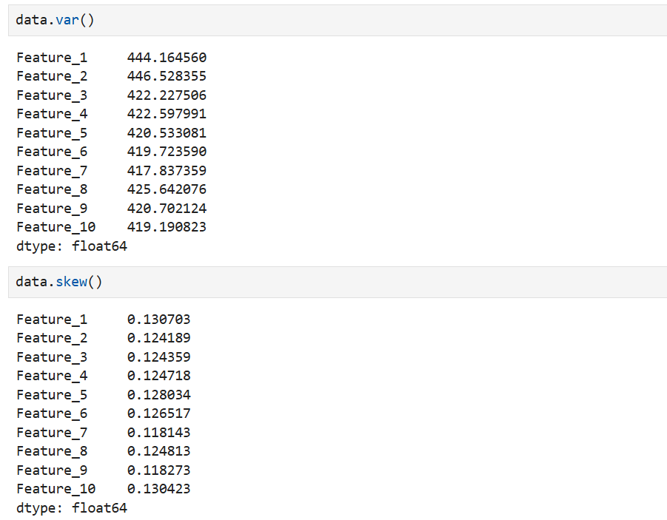
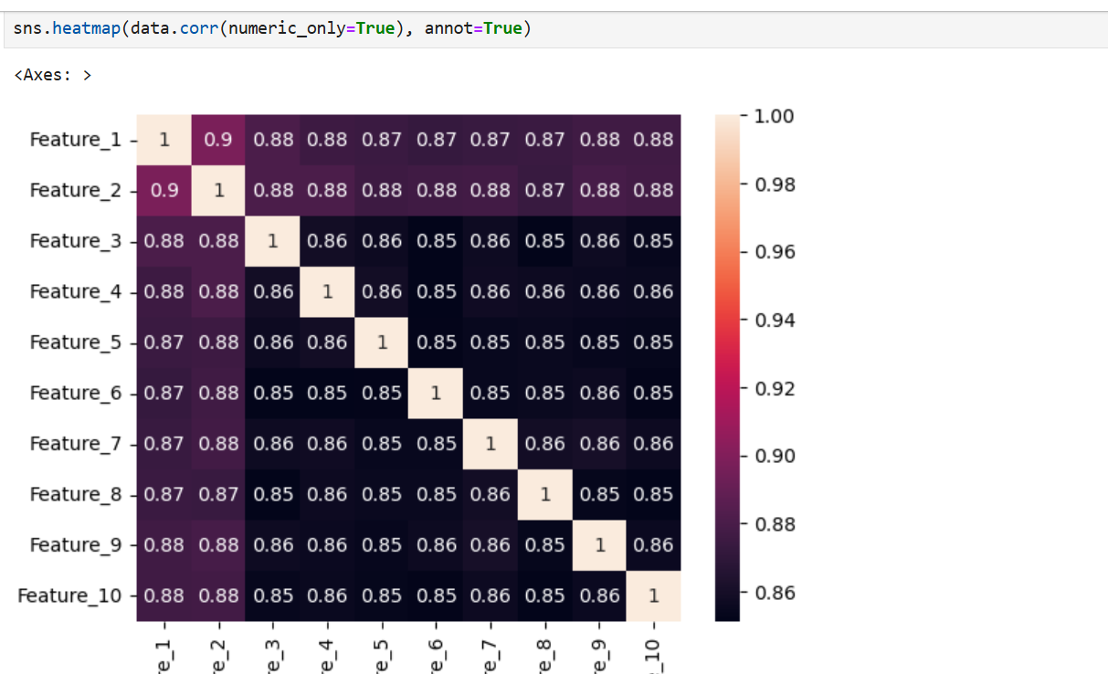
Density Distributions:
I had used histogram plots with Kernal density estimation to check the distribution of features. In the given dataset all features follows multimodal distribution. Multi modal distribution contain two peaks which may indicate the presence of multiple classes present in dataset.
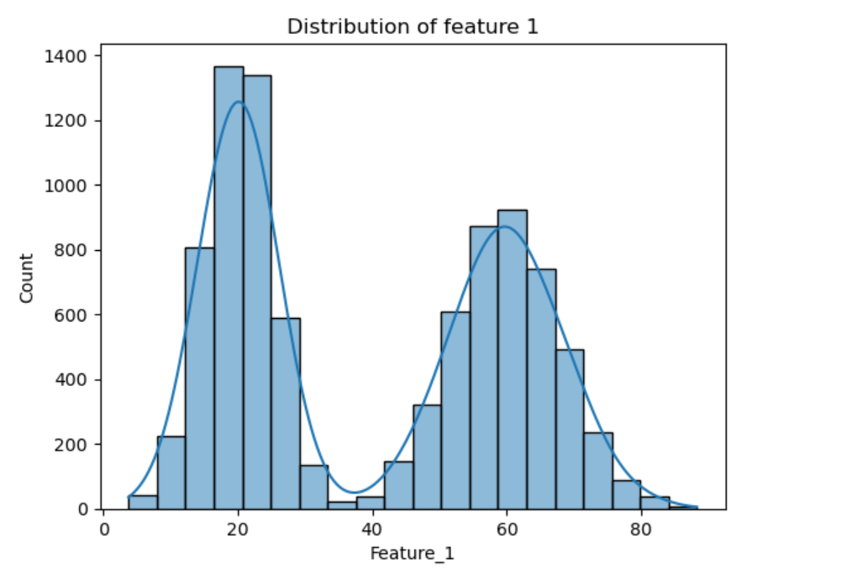
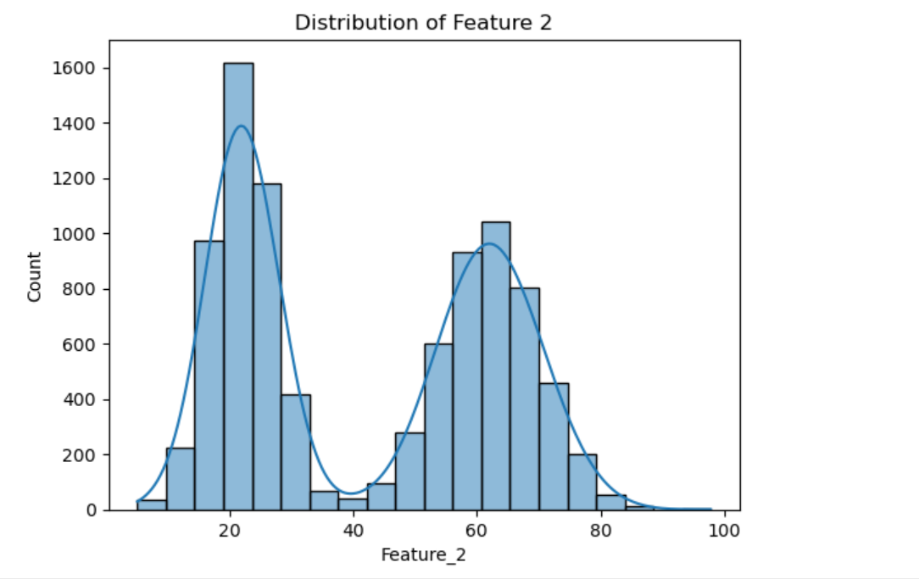
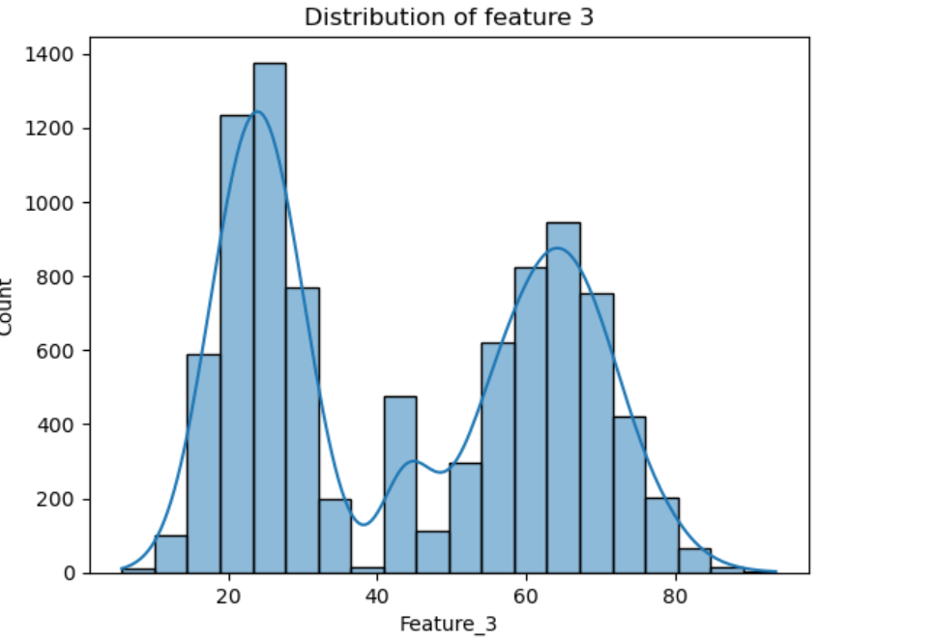
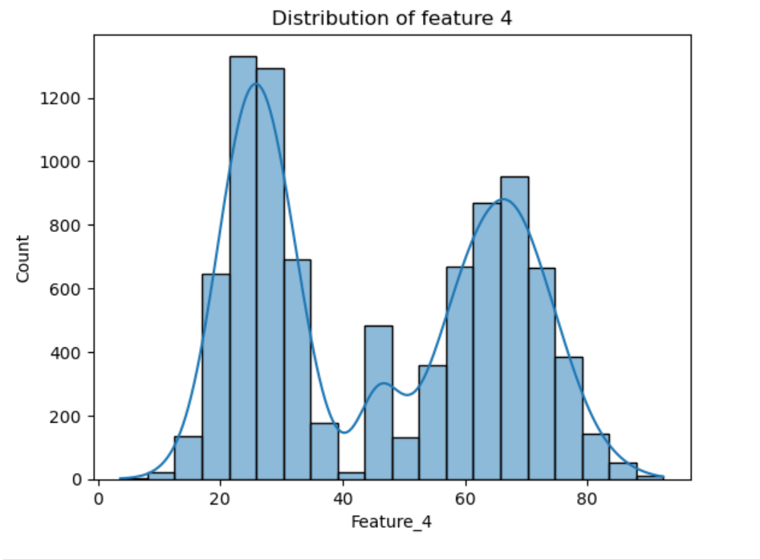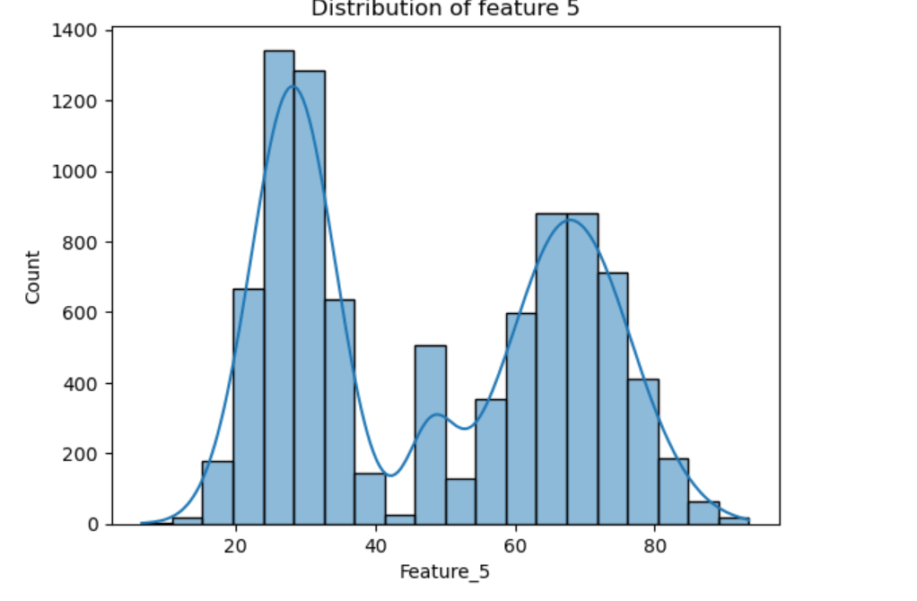
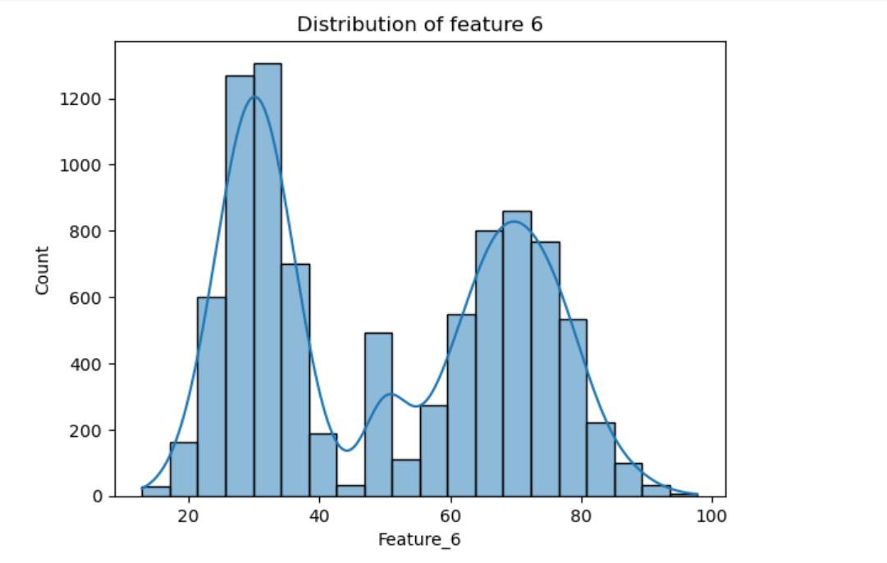
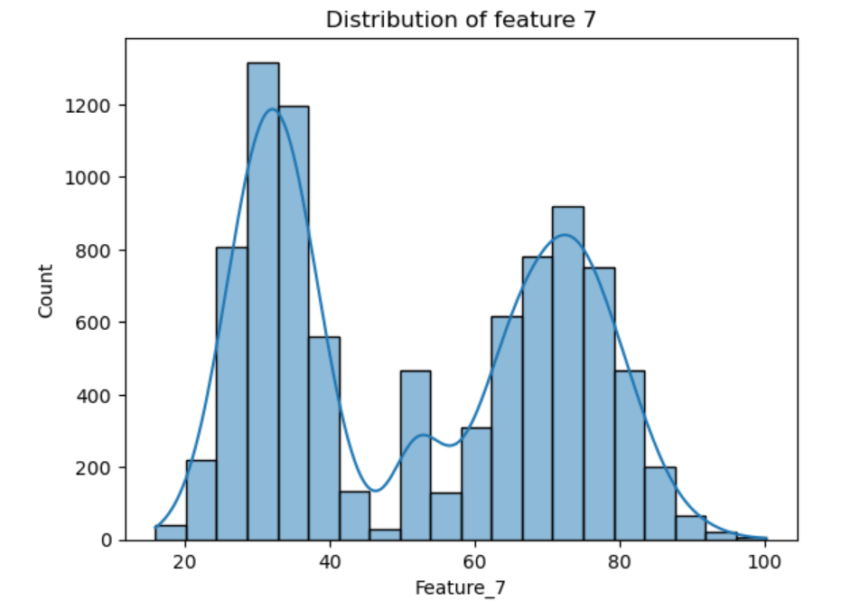
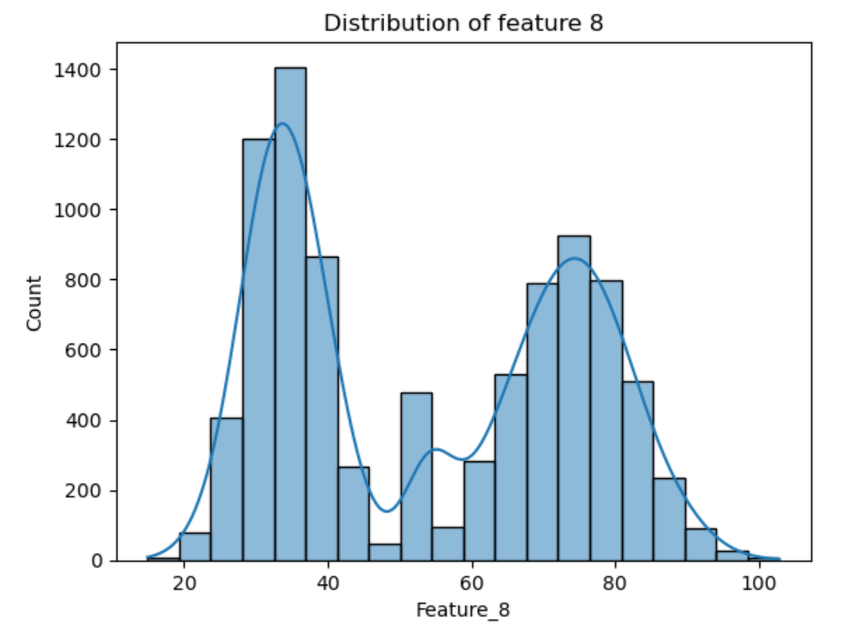
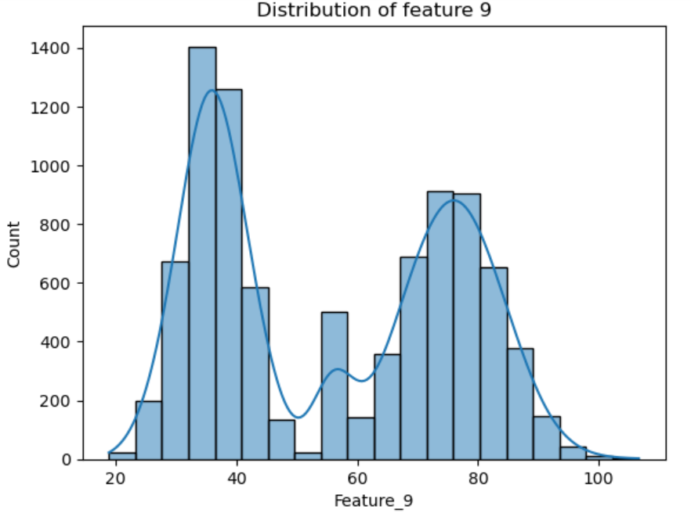
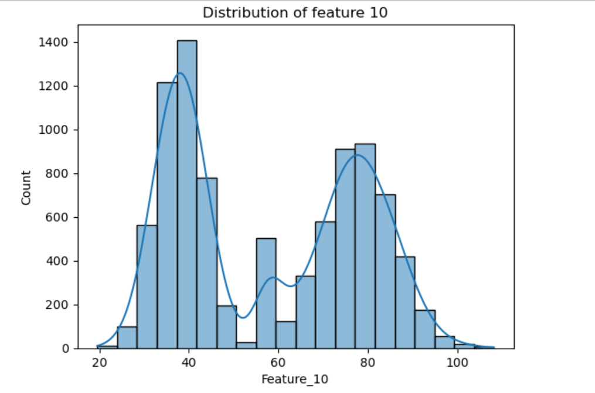
Normal distribution:
Within multimodal distribution, the distribution is also almost normal distribution because skewness is close to 0 as shown in figure below:
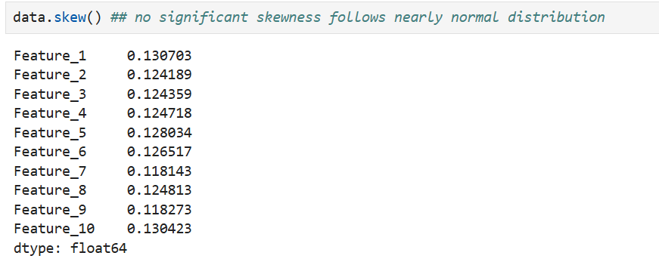

Task 2: Case Study with Real Data (30 Marks):
Using Dataset #2 (CIFAR-10):
• Load the dataset and explain its structure (training/test sets, classes).
• Select any three classes (e.g., airplane, cat, car).
• For each class:

✓ Visualize random samples of images.
✓ Extract simple numerical features (e.g., pixel intensity histograms, mean
RGB values).
✓ Analyze their distributions (normal, skewed, multimodal, etc.).

• Discuss whether CIFAR-10 can be considered IID or Non-IID in your experiments, and
why.
Loading the dataset:
I directly downloaded data from tensor flow and import that CIFAR 10 data in mu jupyter notebook.
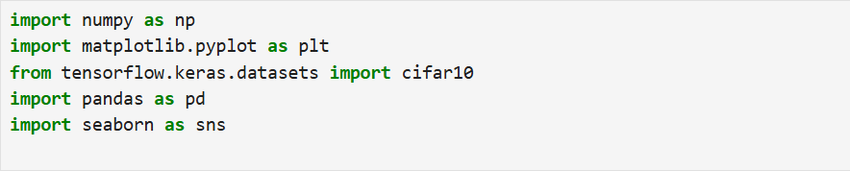
Explain the structure of data:
This CIFAR training dataset consist of 50000 images with 32 by 32 pixels in RGB colors. Test dataset consist of 10000 images with 32 by 32 pixels in RGB colors. The training label consist of 5000 rows and 1 column.
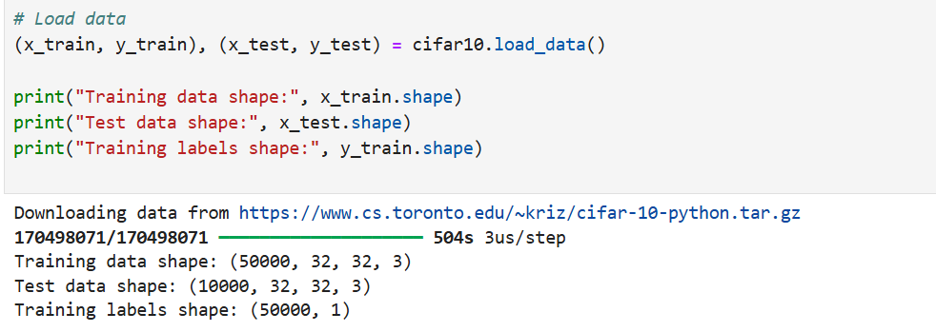
Selection of classes:
I had selected class 1, 2, 3 for displaying of random images and calculating mean RGB values. Class 1 indicate automobile, class 2 indicate bird and class 3 indicate cat.
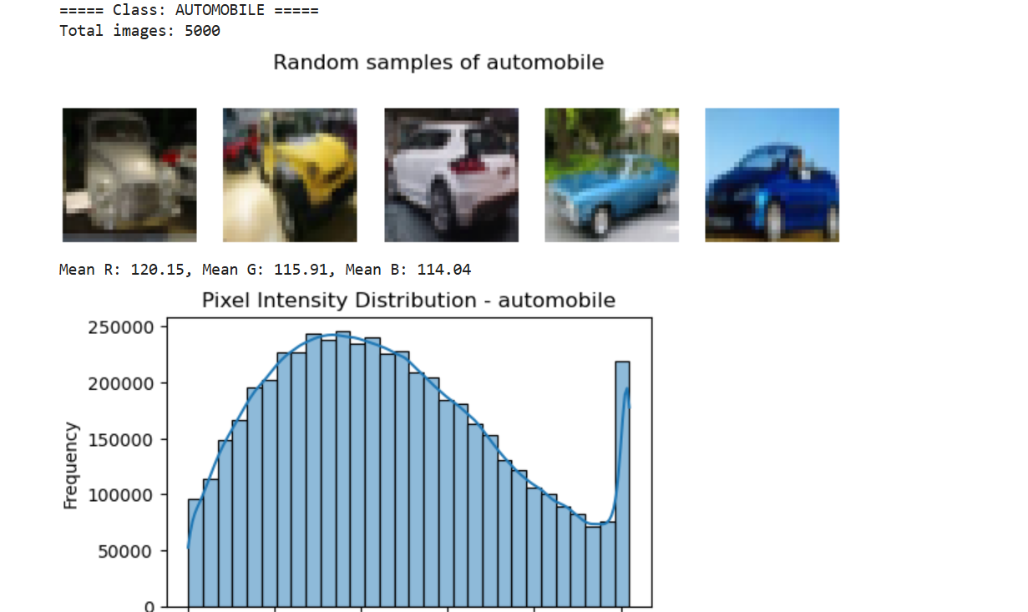
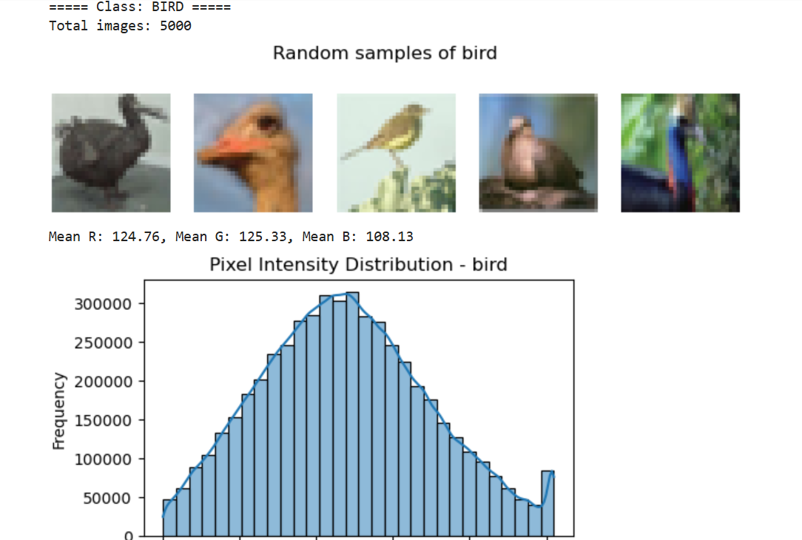
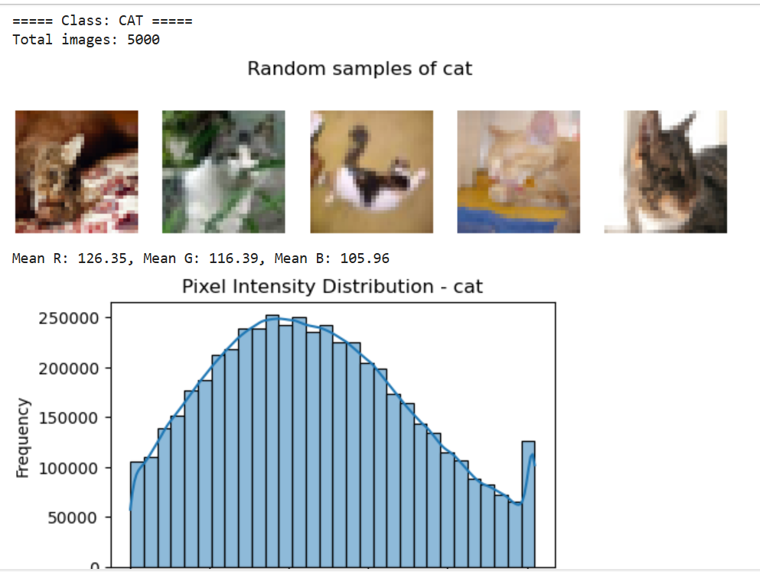
Their Distribution:
All the three classes shows normal distribution because skewness is close to 0.
Distribution analysis of automobile class:
Distribution Analysis of Birds class:
Distribution Analysis of Cat class:
IID distribution:
Yes, this CIFAR 10 dataset present IID distribution because:
- Number of images in each class is equal.
- Images are drawn independently of other class from the sample.
- Pixel intensities are also normally distributed.
Importance of understanding distribution in data science.
Understanding the distribution of dataset is very important in data science because it is :
- Helpful in the selection of right model: Model selection depends upon the distribution of data. For example, linear regression assumes normal distribution of data and Poisson regression assumes Poisson distribution in data.
- Selection of transformation technique: Data distribution helps to determine which transformation technique should be applied on data. For example, if data is rightly skewed then log transform is best.
- Class imbalance issues: Data distribution are also helpful in handling class imbalance issue and provide insight about the data in a more clear way.

